Nama : Kianne Rista Tanayu

NIM : 12030123140214

Mata Kuliah : Pengkodean & Pemrograman

Kelas : D

**TUGAS 1**

**Membuat tampilan SSO**

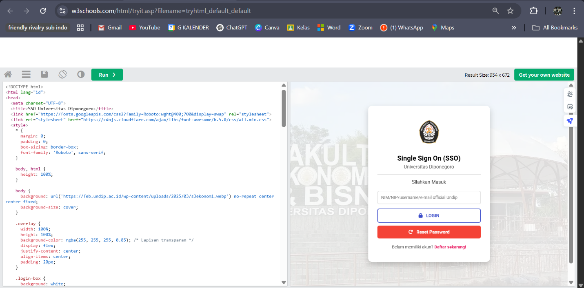

**Codinganya:**

<!DOCTYPE html>

<html lang="id">

<head>

<meta charset="UTF-8">

<title>SSO Universitas Diponegoro</title>

<link href="https://fonts.googleapis.com/css2?family=Roboto:wght@400;700&display=swap" rel="stylesheet">

<link rel="stylesheet" href="https://cdnjs.cloudflare.com/ajax/libs/font-awesome/6.5.0/css/all.min.css">

<style>

* {

margin: 0;

padding: 0;

box-sizing: border-box;

font-family: 'Roboto', sans-serif;

}

body, html {

height: 100%;

}

body {

background: url('https://feb.undip.ac.id/wp-content/uploads/2025/03/s3ekonomi.webp') no-repeat center center fixed;

background-size: cover;

}

.overlay {

width: 100%;

height: 100%;

background-color: rgba(255, 255, 255, 0.85); /* Lapisan transparan */

display: flex;

justify-content: center;

align-items: center;

padding: 20px;

}

.login-box {

background: white;

padding: 40px 30px;

border-radius: 12px;

text-align: center;

width: 100%;

max-width: 400px;

box-shadow: 0 10px 20px rgba(0,0,0,0.2);

}

.login-box img {

width: 90px;

margin-bottom: 15px;

}

.login-box h2 {

font-size: 22px;

margin: 10px 0 0;

font-weight: 700;

}

.login-box h4 {

font-weight: 400;

margin: 5px 0 15px;

color: #555;

}

.login-box hr {

border: none;

height: 1px;

background: #ddd;

margin: 15px 0;

}

.login-box p {

color: #333;

margin: 10px 0 20px;

}

.input-box input {

width: 100%;

padding: 12px;

border: 1px solid #ccc;

border-radius: 6px;

font-size: 14px;

}

.login-btn {

width: 100%;

padding: 12px;

background-color: white;

color: #3B4CCA;

border: 2px solid #3B4CCA;

border-radius: 6px;

font-size: 15px;

font-weight: bold;

margin-top: 15px;

cursor: pointer;

transition: 0.3s;

}

.login-btn i {

margin-right: 8px;

}

.login-btn:hover {

background-color: #3B4CCA;

color: white;

}

.reset-btn {

width: 100%;

padding: 12px;

background-color: #f44336;

color: white;

border: none;

border-radius: 6px;

font-size: 15px;

font-weight: bold;

margin-top: 10px;

cursor: pointer;

transition: 0.3s;

}

.reset-btn i {

margin-right: 8px;

}

.reset-btn:hover {

background-color: #d32f2f;

}

.bottom-text {

margin-top: 20px;

font-size: 14px;

color: #555;

}

.bottom-text a {

color: #e91e63;

text-decoration: none;

font-weight: bold;

}

.footer {

text-align: center;

font-size: 13px;

color: #888;

padding: 20px 0;

background: rgba(255, 255, 255, 0.8);

}

.footer a {

color: #3B4CCA;

text-decoration: none;

}

@media screen and (max-width: 500px) {

.login-box {

padding: 25px 20px;

}

}

</style>

</head>

<body>

<div class="overlay">

<div class="login-box">

<img src="https://i.ibb.co./LdNzS4dq/logo-undip-bulat.png" alt="Logo Undip" style="width: 90px;">

<h2>Single Sign On (SSO)</h2>

<h4>Universitas Diponegoro</h4>

<hr>

<p>Silahkan Masuk</p>

<div class="input-box">

<input type="text" placeholder="NIM/NIP/username/e-mail official Undip">

</div>

<button class="login-btn"><i class="fa fa-lock"></i> LOGIN</button>

<button class="reset-btn"><i class="fa fa-rotate-right"></i> Reset Password</button>

<div class="bottom-text">

Belum memiliki akun? <a href="#">Daftar sekarang!</a>

</div>

</div>

</div>

<div class="footer">

© 2025 DSTI Universitas Diponegoro, <a href="#">All rights reserved</a>.

</div>

</body>

</html>